Needle book

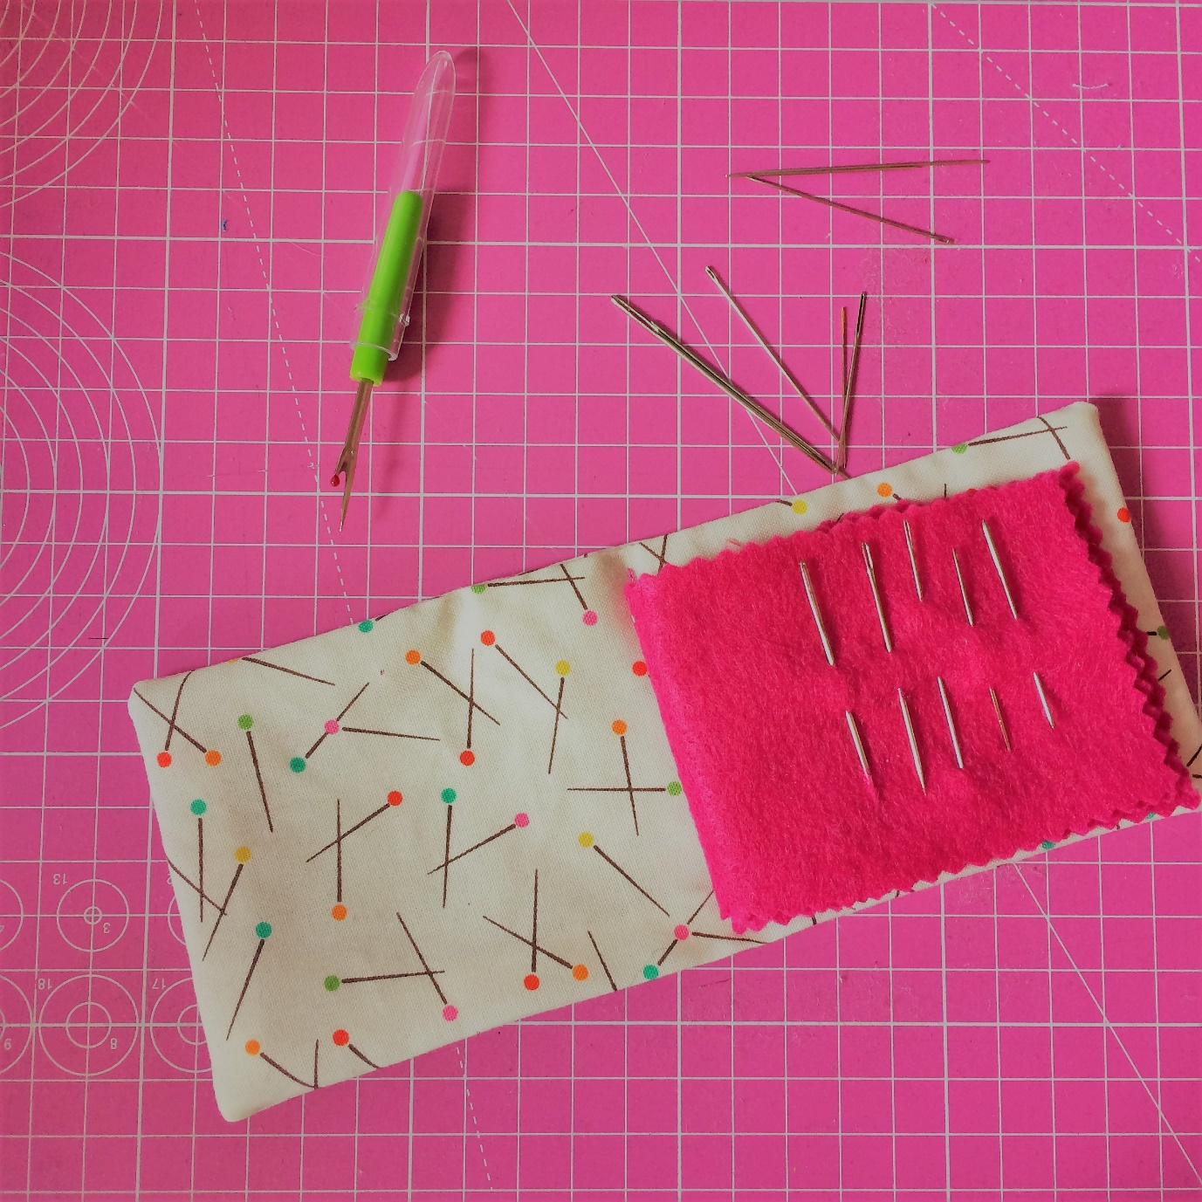

Needle books are so quick to make yet super handy to have around. Maybe not everyone owns as many hand sewing needles as I do but mine used to be strewn all around the house and I could never find them. Now, as long as I don’t lose my entire needle book that is, I always know where to find any size needle I need. Why not make another one for those odd sewing machine needles that you used once so they can’t go back into the packet but you can’t throw it away either? Maybe you can be really organised and label the pages for each kind?

Ingredients:
2 pieces of fabric, 8 x 18cm, for the cover
2 pieces of felt, 6 x 16cm, for the pages:
Interfacing 6x16 (unless you are using a sturdy canvas or denim)
Pinking shears
Recipe:
1 Using pinking shears cut around the tow felt pieces to create a lovely crinkled edge for your needlebook pages
2 Press your interfacing, if using, on to the back of one of the fabric pieces, centering it neatly so there won’t be any interfacing in the seam allowance later.
3 Lay your fabric pieces RST, pin and stitch around the outside edge with a 0.5cm seam allowance, leaving a 3-4cm gap. Make sure you backstitch at both ends. Cut off the corners diagonally.
4 Turn your cover right side out and poke the corners out with something pointy but not sharp. Fold the unstitched edges in and hand-stitch the gap shut.
5 Fold your cover short edges together to determine the middle line and mark this with a pin. Do the same for your felt pages.
6 Using your pins as a guide line up the pages and the cover so the pages are neatly sitting slap bang in the middle of the needle book cover. Use clips to hold the layers together and using a long stitch (3 or 3.5) stitch through all the layers to secure. Maybe use a nice contrasting stitch?
7 You may find that thick felt gives you a central page that sticks out a bit compared to the other page or even the cover. Cut this in line if so. Your pages should be slightly smaller than the cover.

That’s it! Now go and rescue all your poor needles from being stuck in thread spools and on bits of paper and give them a nice new home.

